PDS ASSIGNMENT
Marks 7
Comment and insight missing
Total_score is sum of all scores
For average use inbuilt function

install.packages("cowplot")
install.packages("plotrix")
install.packages("ggplot2")
install.packages("tidyverse")
install.packages("grpby")

library(cowplot)
library(readxl)
library(ggplot2)
library(dplyr)

student_performance = read_excel("C:/Users/neeli/OneDrive/Documents/PDS/Inputs/StudentsPerformance.xlsx")
View(student_performance)
head(student_performance)
tail(student_performance)
summary(student_performance)
nrow(student_performance)
str(student_performance)
print(student_performance)

grp_count = student_performance %>% count(group)
grp_count

student_performance %>% filter(is.na(gender))
student_performance %>% filter(is.na(group))
student_performance %>% filter(gender=='male' & group == 'group B')
student_performance %>% filter(group == 'group B' & math_score == 40)

new_student_performance = mutate(student_performance,average_score = round((math_score+reading_score+writing_score)/3))
new_student_performance$average_score
head(new_student_performance)
View(new_student_performance)

##Solution 1##

agg_reading_score = aggregate(new_student_performance$reading_score, list(student_performance$group), FUN=mean)
colnames(agg_reading_score) <- c('group','avg_reading_score')

agg_math_score = aggregate(new_student_performance$math_score, list(student_performance$group), FUN=mean)
colnames(agg_math_score) <- c('group','avg_math_score')

agg_average_score = aggregate(new_student_performance$average_score, list(student_performance$group), FUN=mean)
colnames(agg_average_score) <- c('group','avg_student_performance')

agg_writing_score = aggregate(new_student_performance$writing_score, list(student_performance$group), FUN=mean)
colnames(agg_writing_score) <- c('group','avg_writing_score')

p1 = ggplot(agg_math_score, aes(x=group, y=avg_math_score, fill=group)) + geom_bar(stat="identity") + labs(x="Groups", y="Average_Math_Score")
p1

p2 = ggplot(agg_reading_score, aes(x=group, y=avg_reading_score,fill=group)) + geom_bar(stat="identity") + labs(x="Groups", y="Average_Reading_Score")
p2

p3 = ggplot(agg_writing_score, aes(x=group, y=avg_writing_score,fill=group)) + geom_bar(stat="identity") + labs(x="Groups", y="Average_Writing_Score")
p3

p4 = ggplot(agg_average_score, aes(x=group, y=avg_student_performance,fill=group)) + geom_bar(stat="identity") + labs(x="Groups", y="Average_Student_Performance")
p4

plot_grid(p1,p2,p3,p4,labels="AUTO")

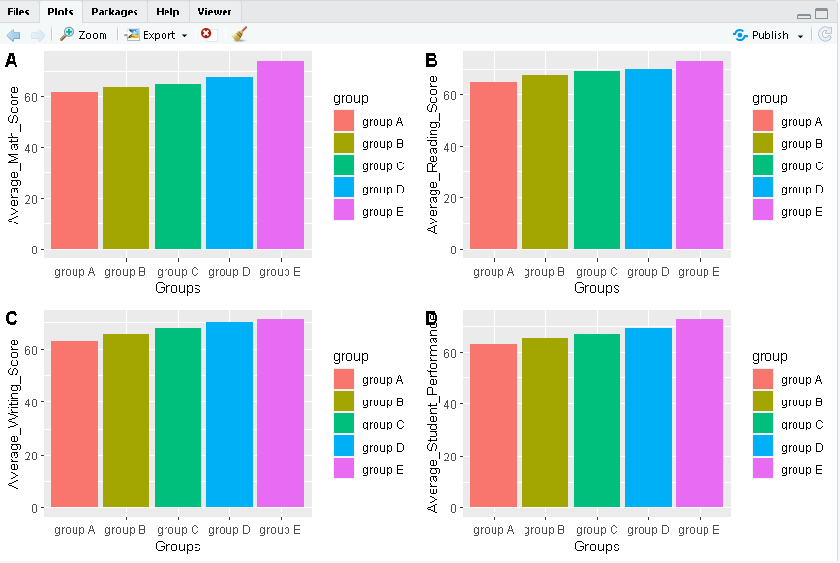

##soulution 2##

grp2_avg = student_performance %>% group_by(group,gender) %>% summarise(avg_math = mean(math_score))
grp2_avg

ggplot(grp2_avg,(aes(x=group,y=avg_math,fill=gender))) +geom_bar(stat = "identity",position = "dodge")

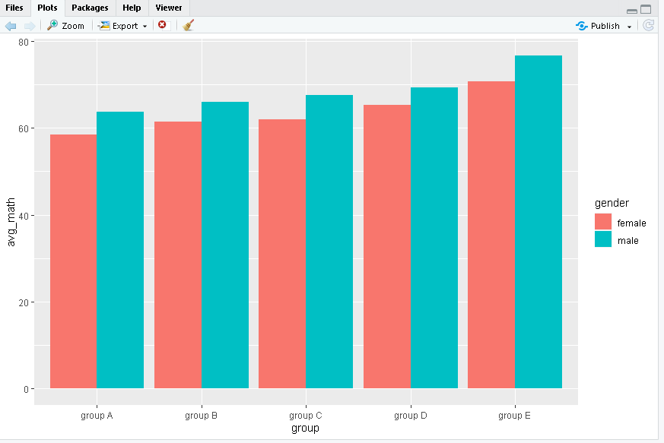

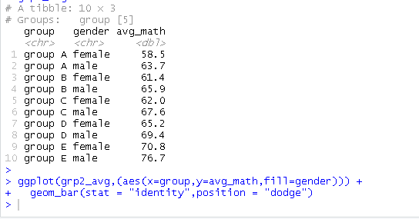

##solution 3##

total_student_performance = mutate(student_performance,total_score = (math_score+ reading_score+ writing_score))
total_student_performance$total_score
head(total_student_performance)

grp3_total = total_student_performance %>% group_by(group,gender) %>% summarise(sum_total = sum(total_score))

ggplot(grp3_total,(aes(x=group,y=sum_total,fill=gender))) +
geom_bar(stat = "identity",position = "dodge")

total_box=ggplot(total_student_performance, mapping=aes(x=group, y=total_score))+geom_boxplot()

total_box=ggplot(total_student_performance, mapping=aes(x=group, y=total_score, fill=gender))+geom_boxplot()

